Title Maximum 15 words, using lowercase letters and capital letters at the beginning of sentences
(Candara, center, bold, 16pt)

First Author¹, Second Author² (Candara, 11 pt)
¹Study Program Name, Institution, Indonesian (Candara, 10 pt)
²Study Program Name, Institution, Indonesian
coresponden author@gmail.com

Abstract. A well-prepared abstract enables the reader to identify the basic content of a document quickly and accurately, to determine its relevance to their interests, and thus to decide whether to read the document in its entirety. The Abstract should be informative and completely self-explanatory, provide a clear statement of the problem, the proposed approach or solution, and point out major findings and conclusions. The Abstract should be 100 to 300 words in length. The abstract should be written in the past tense. Standard nomenclature should be used and abbreviations should be avoided. No literature should be cited. The keyword list provides the opportunity to add keywords, used by the indexing and abstracting services, in addition to those already present in the title. Judicious use of keywords may increase the ease with which interested parties can locate our article. (Candara, Italic, 10 pt). |  | Article History:  Submitted: xxx  Revised: xxx  Accepted: xxx  Published: xxx
Keywords:
First Keywords
Second Keywords
Third Keywords
Fourth keywords
(Keywords : Italicized; Written Alphabetically; 3-5 Words)

INTRODUCTION (Candara, Bold, 12 pt)
The main text format is written on A4 paper (quarto). The text margins from the top and left are 3 cm, and the right and bottom are 2.5 cm. The manuscript is written in a single column, Microsoft Word, single spacing, Book Antiqua 12 pt. The page is written at the bottom right. The article title should be as few words as possible that accurately describe the contents of the paper. Indexing and abstracting services depend on the accuracy of the title, extracting from keywords that are useful in cross-referencing and computer searches.
An article with an inappropriate title may never reach the audience it seeks, meaning the title should be more specific. Abbreviations are allowed in the title, but keywords in the abstract should not be abbreviated.
The introduction should provide a clear background, a clear problem statement, clear objectives, relevant literature on the subject, the proposed approach or solution, and the novelty of the research, i.e., innovation. The introduction should be understandable to colleagues from various disciplines. Foreign language terms are written in italics. The text should be divided into sections, each with a separate title in capital letters and not numbered. If there are section/subsection titles, they should be typed on separate lines, with lowercase letters and capital letters at the beginning of each word and not numbered [3]. There is no literature review, sentences that sound like common definitions are unnecessary. If writing is necessary to link to a concept/theory, it is best to write it directly in the discussion, for example by quoting directly. (Book Antiqua, 12pt)

METHOD
Explaining the chronology of the research includes research methods, research objects, types of data, data collection techniques, population and samples, data analysis used, and others [1,3]. The description of the research process must be supported by references, so that the explanation can be accepted scientifically [2,4]. Formulas/equations, tables/images/graphs are presented in the middle. If the table/image/graph is the result of a quotation, then a source statement is added below it. But if the table/image/graph is the result of research, then the source statement does not need to be included, as shown below and cited in the manuscript.

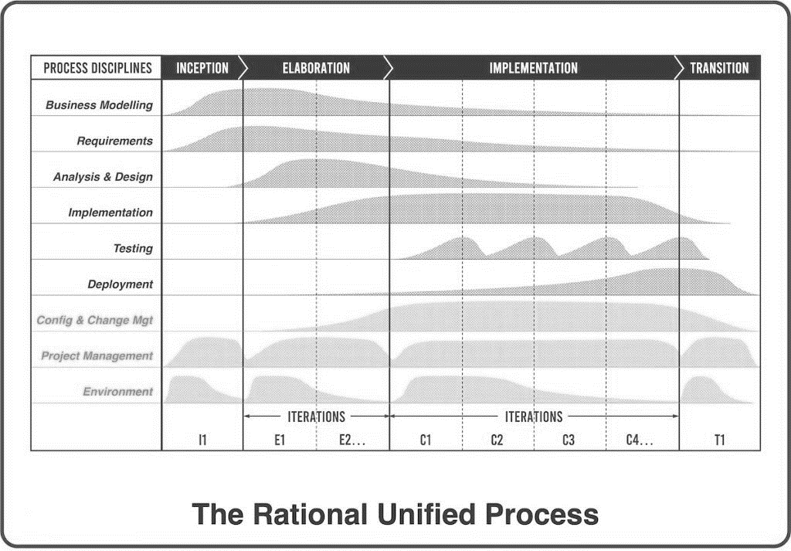

Picture 1. The Rational Unified Process (Book Antiqua, Bold, 11 pt)
Source : Sugiono [4]

${ r}_{xy}(1,2,3)=\frac{b_{1}\sum{X_{1}Y+}b_{2}\sum{X_{2}Y+}b_{3}\sum{X_{3}Y+}}{∑Y^{2}}$ (1)

Tablel 1. The performance of ... (Book Antiqua, Bold, 11 pt)
Variable | Speed (rpm) | Power (kW)
x | 10 | 8.6
y | 15 | 12.4
z | 20 | 15.3
Source : Permana [5]

RESULTS AND DISCUSSION
This section explains the research results and provides a comprehensive discussion. Results can be presented in the form of images, graphs, tables, and other forms to facilitate reader understanding [2, 5]. The discussion can be divided into several sub-chapters.

Subpart 1
The results can be explained in subsections and you can divide them into more groups in many subsections. The results can also be in the form of images, graphs, tables and so on to make it easier for readers [2, 5].

Subpart 2
The results can be explained in subsections and you can divide them into more groups in many subsections. The results can also be in the form of images, graphs, tables and so on to make it easier for readers [2, 5].

CONCLUSION
Provide a statement of expectations, as outlined in the "Introduction" chapter, and ultimately lead to a "Results and Discussion" chapter, to ensure consistency. Furthermore, you can include prospects for developing the research findings and applying them to further studies (based on the results and discussion).

BIBLIOGRAPHY
The primary references are international journals and proceedings. References are written in IEEE style, with 80% from journals and 20% from books (maximum of the last 5-10 years). All references must be to the most relevant, up-to-date sources, with a minimum of 10 references. For plagiarism testing, the maximum is 20%. Please use Mendeley's Reference Manager. Please use a consistent format for references—see example below (12 pt):
[1] A. R. Atmadja and A. Purwarianti, “Comparison on the rule based method and statistical based method on emotion classification for Indonesian Twitter text,” 2015 Int. Conf. Inf. Technol. Syst. Innov. ICITSI 2015 - Proc., 2016, doi: 10.1109/ICITSI.2015.7437692.
[2] Y. A. Gerhana, A. R. Atmadja, W. B. Zulfikar, and N. Ashanti, “The implementation of K-nearest neighbor algorithm in case-based reasoning model for forming automatic answer identity and searching answer similarity of algorithm case,” in 2017 5th International Conference on Cyber and IT Service Management (CITSM), 2017, pp. 1–5, doi: 10.1109/CITSM.2017.8089233.
[3] W. B. Zulfikar, M. Irfan, C. N. Alam, and M. Indra, “The comparation of text mining with Naive Bayes classifier, nearest neighbor, and decision tree to detect Indonesian swear words on Twitter,” in 2017 5th International Conference on Cyber and IT Service Management, CITSM 2017, 2017, doi: 10.1109/CITSM.2017.8089231.
[4] D. S. Maylawati, H. Aulawi, and M. A. Ramdhani, “The Concept of Sequential Pattern Mining for Text,” in AASEC 2018, 2018.
[5] M. Irfan, J. P. Syopiansyah, and A. R. Muhammad, “The Readiness Model of Information Technology Implementation among Universities in Indonesia,” IOP Conf. Ser. Mater. Sci. Eng., 2018.

